

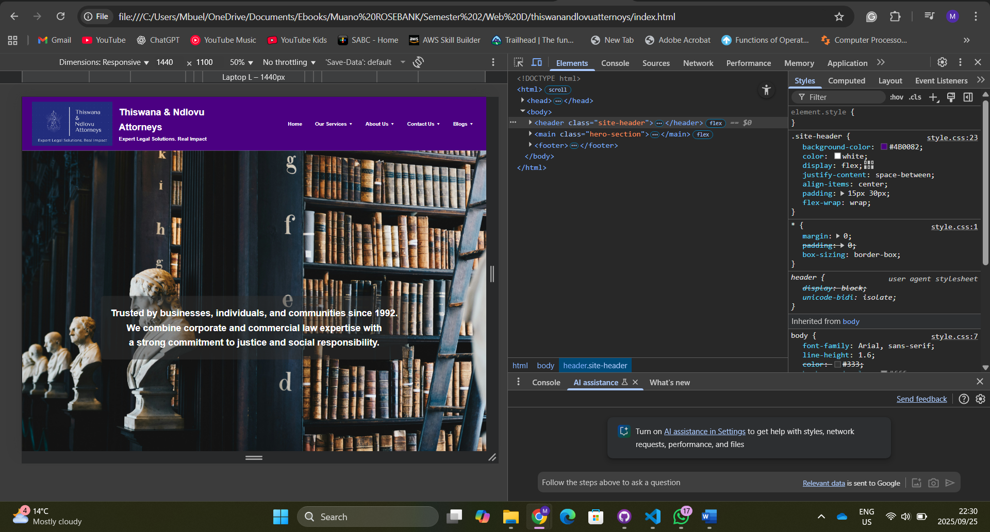

Laptop screen with resolution of 1440 x 1100.

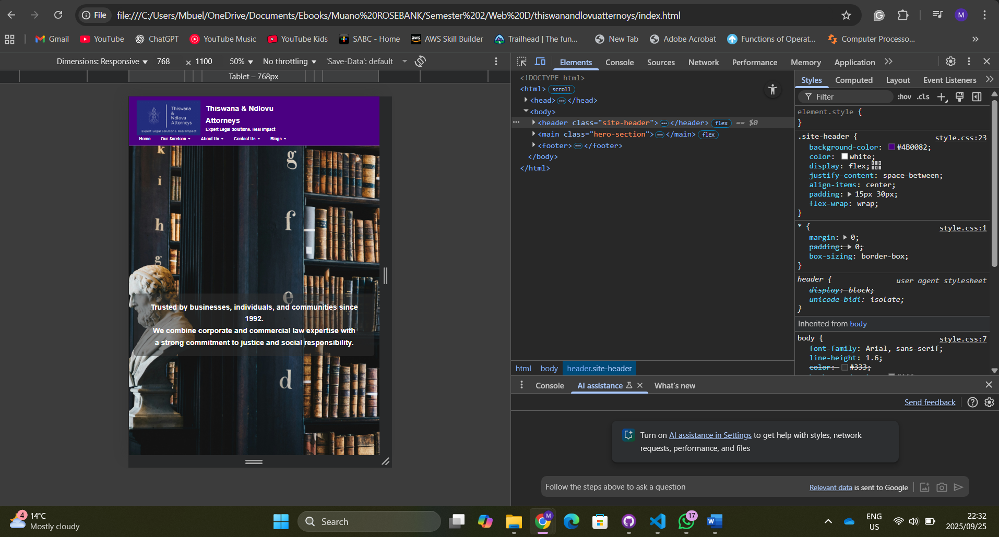

Tablet screen with a resolution of 768 x 1100.

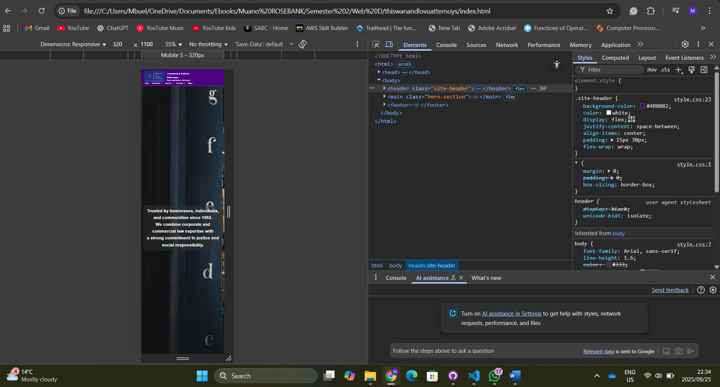

A phone screen with a resolution of 320 x 1100.